ICTPMG613 AssessmentTask

Project Name:

Strategic Plan Technological modernisation of software, hardware systems and Design, implementation of a modern website at Boutique Build Australia

at Boutique Build Australia

Manuel Sergio Perez Espitia

13/07/2055

Executive Summary

Established in 2010, Boutique Build Australia is a building company specialising in the design and building of high-quality designer homes for the Sydney metropolitan and surrounding areas.

Our vision – to be the best home builder in Australia – drives everything we do, from the friendly greeting we give to customers at our display centre, to our supplier relationships and to our employees’ professional development.

Vision

To be the best quality home builder in Australia.

Our values are:

The core values underpinning our activities are:

* Quality
* Innovation
* Leadership
* Respect
* Honesty and reliability

Our policies:

In order to meet our core values, we have policies in these areas:

* Quality control
* High-quality and timely customer service
* Continuous improvement
* Customer complaints and feedback
* Respectful, sensitive and transparent work practices
* Work health and safety, to protect our staff and our customers
* Compliance against relevant Australian Standards, state and federal legislation and regulations

Strategic Goals

**To be well led, high performing, profitable and accountable**

* Ensure that all financial operations, performance indicators and results support the strategic policies
* Identify new and expand existing sources of revenue
* Achieve profits of at least 10% per annum
* Increase sales of homes in current Sydney market by 10% per annum over the next three years
* Establish a presence in Queensland and build at least 100 new homes in Brisbane and its surrounding areas during the period of the Strategic Plan, beginning 2020
* Plan expansion into other Australian states and territories during the second half of 2021.

**Set up and operate a permanent model home**

* Give potential customers the experience of being in a high-quality home
* Demonstrate new environmentally friendly building techniques
* Provide a point of reference for customers
* Improve brand recognition.

**Attract, engage and develop the best staff**

* Continuing the drive to a customer centred, high performance workforce and culture
* Strengthening the skills of our people, to better support customer needs
* Continuing to enhance the diversity of our workforce.

Situation Analysis

|  |  |
| --- | --- |
| **Strengths** | **Weaknesses** |
| * Value and quality * Strong management * Customer loyalty * Friendly organisational culture * Level of available finance for investment | * Focus on Sydney market only * Brand name not developed as yet * High turnover of casual workforce * Poor IT infrastructure * Lack of diversity in workforce |
| **Opportunities** | **Threats** |
| * Housing sector experiencing growth * Potential for growth in Brisbane and Sunshine Coast market * Innovation in environmental housing * Many advertising channels unexplored | * Environmental effects * Changes in Industry/ Government legislation affecting construction industry * Possible adverse effects of government policy formulation * High level of competition * Predicted uncertainties in the world economy impacting level of demand for housing * Low price competitors * Failing to satisfy client demands |

Marketing Strategies

Our marketing strategies aim to:

* build trust
* generate leads now and convert those leads quickly
* demonstrate our commitment to deeper customer engagement.

We plan to develop our market share by:

* Improving our marketing and advertising
* Setting up a permanent model home near a popular shopping centre to increase interaction with potential customers.
* Placing brand recognition advertisements in the Sydney Domain Magazine
* Continually improving communication channels with all our stakehlegacys, ensuring a flow of timely and accurate information to facilitate effective planning and decision making
* Targeting identified growth markets with planned, market appropriate campaigns employing a variety of promotional strategies and advertising mediums
* Offering attractive fee structures to our clients
* Continually improving the skills, knowledge and effectiveness of Boutique Build Australia through our commitment to training and development
* Regularly reviewing the effectiveness of all our operations and making improvements when and where necessary.

Project management plan

Project overview

The project consists of two sub-projects, which will be implemented in parallel. I have named the project Technological modernisation of software, hardware systems and Design, implementation of a modern website at Boutique Build Australia.

I as a part of IT Biz Solutions teamwork working as a Project Manager and we have been contracted by Boutique Build Australia for implement both projects.

The client is a small company based in Sydney with expansion plans into Queensland within the next three years. They aim to replace their entire current infrastructure to support their growth objectives, and intend to achieve this through the following projects:

* Scaling their operations
* Strengthening the security of their IT systems
* Improving connectivity for their employees

Due to a recent technological incident, their reputation was negatively affected. As a result, they now seek to update all their hardware and software with the goals of:

* Increasing efficiency
* Improving productivity
* Maximizing performance

The client wishes to undertake two projects that must meet the following objectives:

* Ensure that the business always remains operational
* Maintain remote connectivity for all employees
* Have a high-quality website that reflects a strong brand image

The client has a clear vision of what they want. They are going to fund the full cost of the projects upfront, with allocated budgets of $40,000 and $10,000 respectively. The client has made it clear that these budgets are non-negotiable, and they have also provided specific hardware and software components that must be used.

So this is a project with the following characteristics:

* Non-negotiable budgets
* Clear objectives
* Well-defined requirements
* A defined project team
* No fixed project completion date, offering time flexibility up to 3 years
* The scope is not clearly defined and is considered flexible

Additionally, for the first project:

* Migration can be performed in stages

On the other hand, for the second project:

* The website can be built in modules or iterations

Project methodology

The approach chosen for the project is a hybrid model, waterfall and scrum. In the implementation phase, the project will be divided into two phases that will be worked on in parallel: 1) infrastructure migration and provisioning of new work devices, and 2) website development. The first project will continue to be managed using the Waterfall methodology, while the second will be managed using Sprints.

Given the characteristics of the projects, in summary, they present the following attributes:

* Fixed budget
* Clear objectives
* Well-defined requirements
* A defined project team
* Time flexibility
* Infrastructure migration can be performed in stages
* The website can be developed in parallel

The project methodology to be used could range from a traditional approach, such as Waterfall, to a deliverable-based approach offered by Agile, Scrum, or Kanban.

To make an informed decision, I considered the following factors:

* The Triple Constraint Triangle (scope, time, cost)
* The project team’s experience in previous implementations
* A yellow triangle with white text

  AI-generated content may be incorrect.Industry best practices and recommendations for similar projects

According to the Triple Constraint Triangle, it becomes clear that two different yet complementary methodologies are needed. Market recommendations suggest using Waterfall and Agile, respectively, for each project.

Waterfall is well-suited for a project with strict constraints, where tasks can be carried out in a linear and structured sequence.

Finally, based on my own experience, an Agile methodology is ideal for software development. Therefore, I have chosen to apply Scrum, as I have several years of experience using this methodology in similar projects.

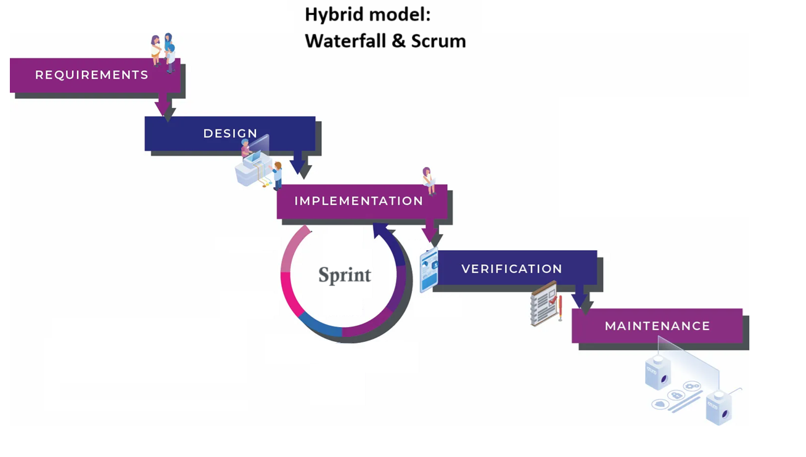

References:

* <https://www.teamwork.com/project-management-guide/project-management-methodologies/>
* <https://www.pmi.org/learning/library/beyond-iron-triangle-year-zero-6381>
* <https://www.pmi.org/learning/library/tailoring-benefits-project-management-methodology-11133>

Objectives

* Scaling their operations
* Strengthening the security of their IT systems
* Improving connectivity for their employees
* Increasing efficiency
* Improving productivity
* Maximizing performance

Assumptions and constraints

* The project should be completed before the company’s planned expansion within the next three years, so the timeline is considered flexible
* The scope of the first project is considered fixed, as the client already knows the expected outcome and has decided which technologies to use
* The scope of the second project is considered flexible, since the client has not provided detailed specifications or technical preferences, allowing the development to be adapted as needed
* The budget is fixed ($40,000 and $10,000) and cannot be changed, as clearly stated in the project documentation
* The client requires that the entire infrastructure be cloud-based
* The core applications must be developed, deployed, and fully functional within the new cloud platform
* Training is our responsibility. We must train the staff and provide all necessary manuals and documentation accordingly
* Issue support of legacy systems, legacy applications, legacy hardware, legacy infrastructure and legacy software will not be provided
* No software tools will be developed to connect legacy systems to new ones.
* Issue support for project deliverables will end upon project completion.

Deliverables

* Complete the migration of databases to a cloud platform
* Deliver a new IT infrastructure that is cloud-based, scalable, and fault-tolerant
* Develop and deploy core core applications to the new cloud environment
* Develop a modern, high-quality, engaging and stylish website that enhances the company’s brand image
* Provide documentation and deliver staff training
* Implement remote access tools to ensure secure connectivity for all staff
* Distribute and configure new work devices.

Scope

The scope of this project includes the planning, design, and development of core business applications, the migration of the existing infrastructure to a cloud-based platform, the design and development of a new website, and the migration of all data to the new cloud platform. Additionally, it includes the deployment of all developments onto the cloud platform, as well as the delivery of remote connectivity tools and new, fully configured work devices.

The new cloud platform and the modern website will meet the client's expectations by enabling them to rapidly scale their operations, improve employee connectivity, and greatly enhance the security of their IT systems. The new website will have a modern and high-quality design that will serve as an effective channel to attract new customers. Both the platform and the website will be fault-tolerant, ensuring that business operations remain uninterrupted.

The scope also includes all necessary configuration for the operation of the cloud infrastructure, including the business applications and remote access tools, as well as the development of manuals and staff training sessions.

The project does not include support for legacy applications/systems, nor will any tools be developed to integrate the new systems with the legacy infrastructure. All support and responsibility will conclude upon the finalisation of the project.

Roles and responsibilities

| **Name** | **Role** | **Responsibilities** |
| --- | --- | --- |
| Manuel Sergio Perez E | Senior IT Project Manager | * Develop and manage the project * Liaise with CEO and Operations Manager of Boutique Build Australia * Monitor project progress * Performance manage the team |
| Richard Kuoch | Project Oversight Mentor | * General review |
| Roland Morris | Assistant Project Manager | * Provide information from project manager to the team * Keep team focused during meetings * Ensures project schedule is being met * Refers to project manager where difficulties are encountered |
| Zakary Pineda | Hardware Specialist | * Order and acquire hardware as per project resources requirements * Configures hardware to specifications * Installs hardware * Tests hardware * Refers to Assistant Project Manager |
| Dani Chen | Software Specialist | * Order and acquire software as per project resources requirements * Installs software * Sets up user accounts * Configures software * Tests software * Refers to Assistant Project Manager * Designs and builds website as per WBS * Refers to Assistant Project Manager |
| Ben Nguyen | Project Assistant | * Provide information from project manager to the team about web-design * Keep web-design team focused during meetings * Ensures web-design project schedule is being met * Refers to project manager where difficulties are encountered |
| Judith Lee | Project Sponsor | * Provide funding and final approval of the project * Define the vision and strategic objectives * Authorise key decisions * Ensure project alignment with business objectives * Approve final project delivery |
| Ishtar Kahn | Business Owner | * Provide high-level strategic direction * Participate in major reviews. * Validate functional deliverables. * Provide timely feedback * Confirm that the product meets business needs * Monitor the project's impact on the business * Provide business-specific knowledge * Represent the company's interests during execution |
| Susan Morgan | Customer Service Manager | * Approve the design and web functionalities * Review the visual and aesthetic quality * Review usability and user experience (UX) * Verify the website's functionality |

Risk management plan

| **Risk** | **Likelihood** | **Severity** | **Treatment/control methods** |
| --- | --- | --- | --- |
| Data loss during migration | Medium | **High** | * Perform the migration in phases * Establish agreements with the cloud provider to ensure support and resource availability |
| Incompatibility between legacy data and new applications | Medium | Medium | * Create multiple full backups before migration * Following strong data security policies * Follow the cloud provider's migration recommendations * Perform a complete data review; Normalize data and perform compatibility testing * Use a database engine that has native or certified compatibility with legacy systems |
| Excessive and complex training time for employees | Medium | **High** | * Create a plan for the topics to be covered in the training and request client approval * List employees' technical skills to design training with the appropriate focus * Request and implement feedback * Design training by modules and include didactic information for easy understanding |
| Excessive effort in website development | Medium High | Medium High | * Create web mock-ups and adjust them with the client |
| Budget overruns due to unexpected technical requirements or lengthy development processes | **High** | **High** | * All changes that affect scope and budget must be made by the client through a Change Order * Strict budget monitoring * Established contracts with vendors |
| Security vulnerabilities in the cloud platform | Medium High | **High** | * Follow cloud security best practices * Implement security solutions certified by the cloud provider |
| Work devices delivery delays from vendors | Low Medium | **High** | * Use devices that are available in the near area, are supported, and have a guaranteed contingency stock |
| Performance, stability, and scalability issues during implementation | Medium | Medium | * Perform performance testing after a major deployment and adjust cloud systems as needed * Monitor systems * Manually adjust system scaling to avoid unforeseen expenses |
| Overburdening teams due to running both projects in parallel | **High** | **High** | * Conduct cross-project planning meetings * Track resource allocation. |

|  |  |  |  |  |  |  |
| --- | --- | --- | --- | --- | --- | --- |
| **Likelihood** |  | **Impact** | | | | |
|  | Negligible | Minor | Moderate | Significant | Severe |
| Very likely | Low Medium | Medium | Medium High | High | High |
| Likely | Low | Low Medium | Medium | Medium High | High |
| Possible | Low | Low Medium | Medium | Medium High | Medium High |
| Unlikely | Low | Low Medium | Low Medium | Medium | Medium High |
| Very unlikely | Low | Low | Low Medium | Medium | Medium |